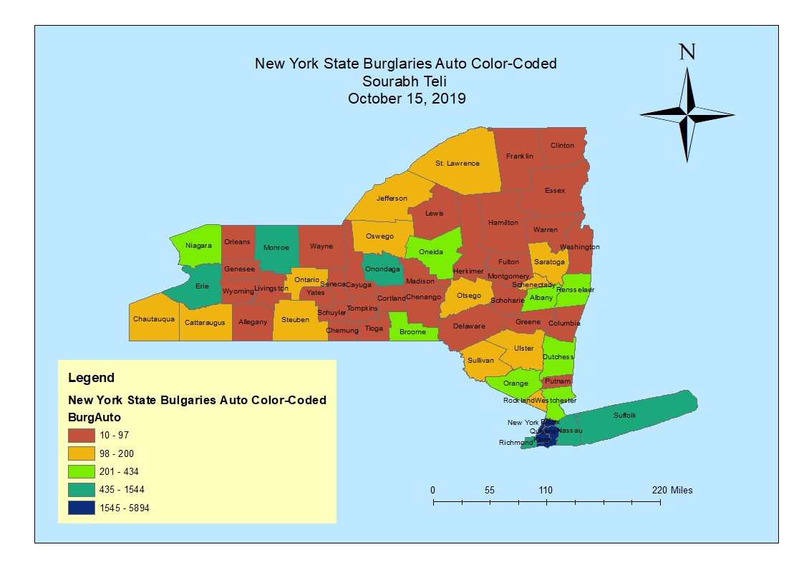

MAP 01: New York State Burglaries Auto Color-Coded

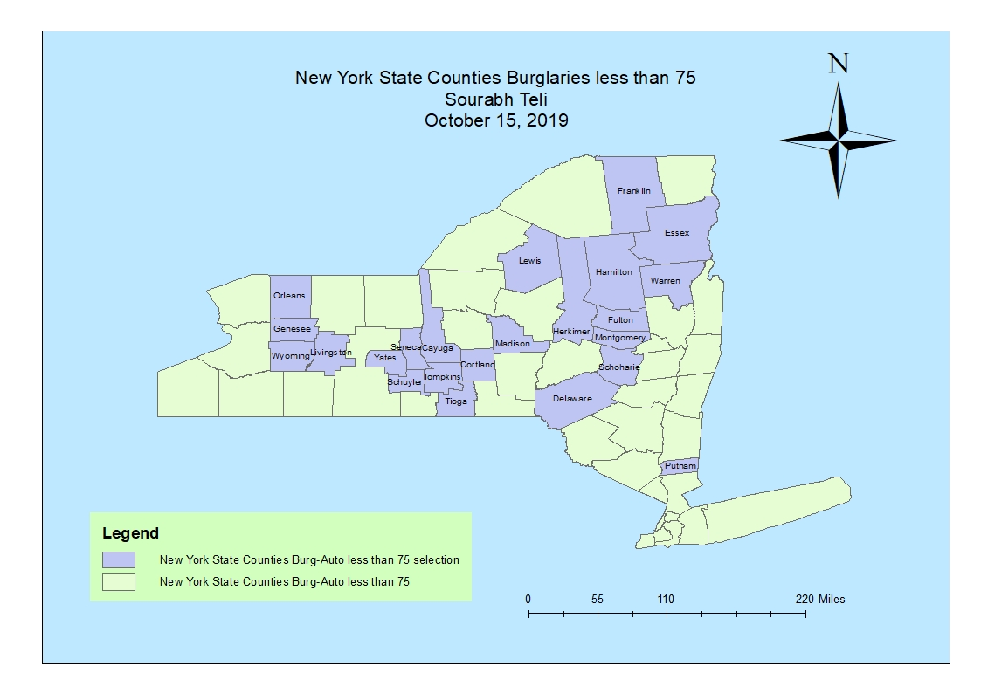

MAP 02: New York State Counties Burglaries less than 75

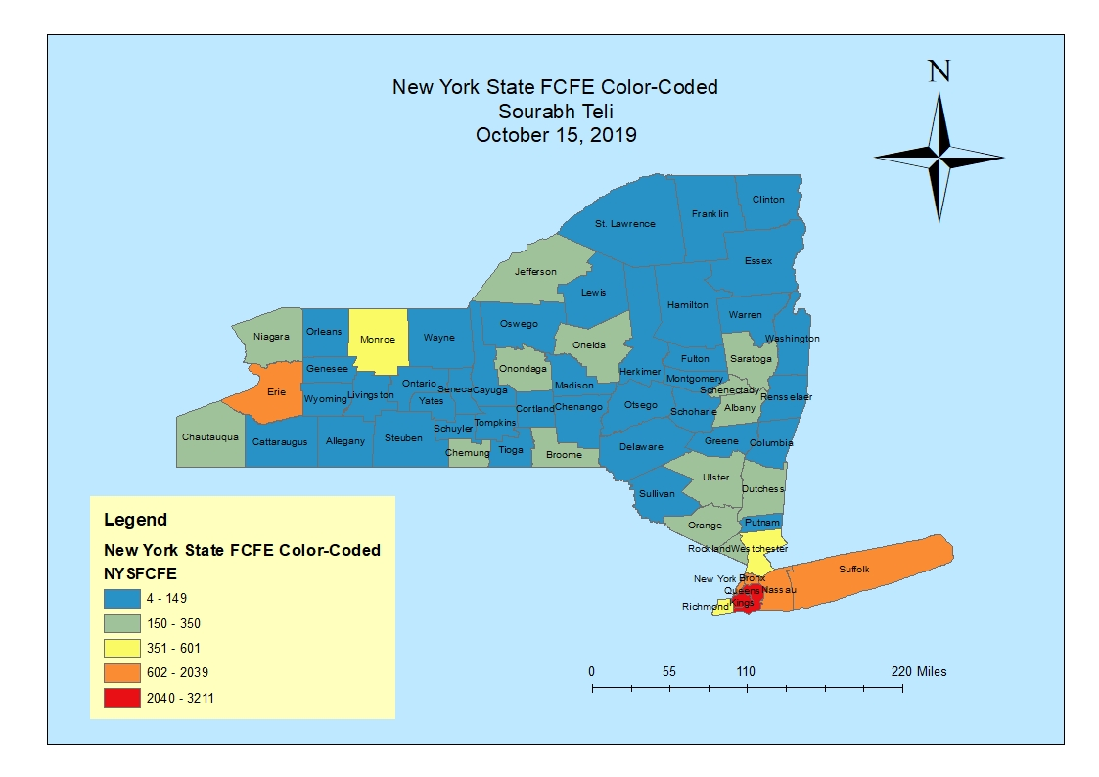

MAP 03: New York State FCFE Color-Coded

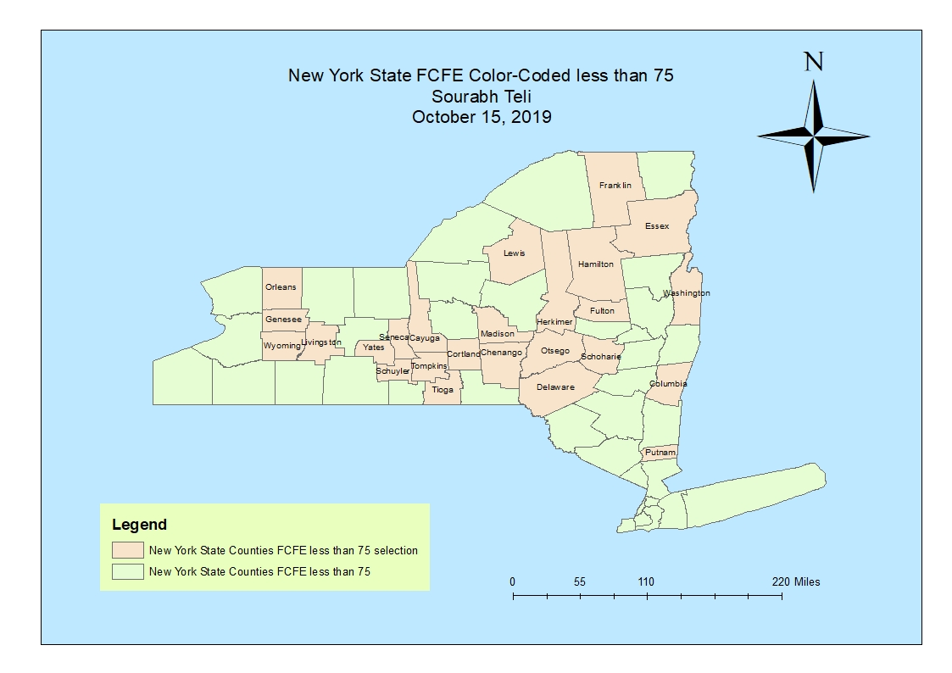

MAP 04: New York State FCFE color coded less than 75